

Darshan University

A Project Report on

“Exam Management System”

Under the subject

Software Engineering (2301CS405)

B. Tech, Semester – IV

Computer Science & Engineering Department

Submitted By
Student Name: Baru Priyanshi. | Enrollment No: 23031701004
Academic Year
(2024-2025)
Internal Guide  Prof. R. B. Gondaliya  Darshan University | Dean-DIET  Dr. Gopi Sanghani  Darshan University

 | Computer Science & Engineering Department  Darshan University

DECLARATION

We hereby declare that the SRS, submitted along with the Software Engineering (2301CS405) for entitled “Exam management system” submitted in partial fulfilment for the Semester-5 of Bachelor Technology (B. Tech) in Computer Science and Engineering (CSE) Department to Darshan University, Rajkot, is a record of the work carried out at Darshan University, Rajkot under the supervision of R. B. Gondaliya and that no part of any of report has been directly copied from any students’ reports, without providing due reference.

(Baru Priyanshi)

Priyanshi Y.
Student’s Signature

Date: 01-03-2025

 | Computer Science & Engineering Department  Darshan University

CERTIFICATE

This is to certify that the SRS on “Exam Management System” has been satisfactorily prepared by Priyanshi (23031701004) under my guidance in the fulfillment of the course Software Engineering (2301CS405) work during the academic year 2024-2025.

Internal Guide  Prof. R. B. Gondaliya  Darshan University |  | Dean-DIET  Dr. Gopi Sanghani  Darshan University

Acknowledgement
I wish to express my sincere gratitude to my project guide Prof. R. B. Gondaliya and all the faculty members for helping me through my project by giving me the necessary suggestions and advices along with their valuable co- ordination in completing this work.

I also thank my parents, friends and all the members of the family for their precious support and encouragement which they had provided in completion of my work. In addition to that, I would also like to mention the Darshan University personals who gave me the permission to use and experience the valuable resources required for the project from the University premises.

Thus, in conclusion to the above said, I once again thank the faculties and members of Darshan University for their valuable support in completion of the project.

Thanking You
Priyanshi

ABSTRACT
An Exam Management System (EMS) is a software solution that facilitates the administration, scheduling, management, and grading of exams for educational institutions or organizations. The system ensures the efficient handling of various activities related to exams, including registration, question paper generation, exam scheduling, monitoring, result processing, and report generation. The goal is to automate and streamline these processes to improve accuracy, save time, and provide a seamless experience for students, faculty, and administrators. The system is developed to address common challenges faced in managing exams, such as handling large volumes of student data, preventing errors, ensuring timely result generation, and maintaining the security and integrity of exam-related information. The EMS aims to eliminate the complexities and inefficiencies associated with paper-based systems, while providing real-time insights into exam performance and administrative workflows.
Main purpose of this system is to reduce human efforts as much as possible.

Table of Contents
List of Figures I
List of Tables II
1 Introduction 1
1.1 Product perspective 1
1.2 Product features 1
1.2.1 There are three different users who will be using this product: 1
1.2.2 The features that are required for the Supervisor are: 1
1.2.3 The features that are required for the student are: 1
1.3 Functional Requirement 1
1.3.1 Students 1
1.3.2 Supervisor 2
1.3.3 Admin 2
1.4 Non-Functional Requirement 3
1.4.1 Performance Requirements: 3
1.4.2 Availability and Reliability: 3
1.4.3 Security Requirements: 3
1.4.4 Usability Requirements: 3
1.4.5 Scalability Requirements: 4
2 Design and Implementation Constraints 5
2.1 Use case diagram 5
2.2 Activity diagram and Swimlane diagram 6
2.3 Sequence diagram 8
2.4 State diagram 11
2.5 Class diagram 11
2.6 Data flow diagram 12
2.6.1 Context diagram (level-0) 12
2.6.2 DFD Level-1 13
3 External interface requirement (Screens) 14
3.1 Screen-1: Registration Form 14
3.2 Screen-2: Exam Schedule Form 16
3.3 Screen-3: Retake exam Form 18
3.4 Screen-4: Profile Update Form 20
3.5 Screen-5: Exam Grade Entry Form 22
3.6 Screen-6: Create Examiner and Invigilator Accounts 24
24
3.7 Screen-7: Respond to User Queries 25
4 Database design 27
4.1 List of Tables 27
5 Stories and Scenario 29
5.1 Story-1: Add New Exam in Exam Management System 29
5.1.1 Scenario# S1.1 29
5.1.2 Scenario# S1.2 30
5.1.3 Scenario# S1.3 30
5.2 Story-2: View Exam Schedule 31
5.2.1 Scenario# S2.1 31
5.2.2 Scenario# S2.2 31
5.2.3 Scenario# S2.3 31
5.3 Story-3: Update Exam Details in the Exam Management System 32
5.3.1 Scenario# S3.1 32
5.3.2 Scenario# S3.2 32
5.3.3 Scenario# S3.3 33
6 Test cases 34
7 References 36

List of Figures

Figure 2.1-1 Use case diagram for exam management system 5
Figure 2.2-1 Activity diagram for exam registration 6
Figure 2.2-2 Swimlane diagram for giving exam 8
Figure 2.3-1 Sequence diagram for giving exam 9
Figure 2.4-1 State diagram of Exam 11
Figure 2.4-2 State diagram for Librarian Error! Bookmark not defined.
Figure 2.5-1 Class diagram for exam management system 11
Figure 2.6-1 Context diagram for exam management system 12
Figure 2.6-2 DFD level-1 for exam management system 13
Figure 3.1-1 Screen-1: Registration Form 14
Figure 3.2-1 Screen-2: Exam Schedule Form 16
Figure 3.3-1 Screen-3: Retake Exam Form 18
Figure 3.4-1 Screen-4: Result Form 20
Figure 3.5-1 Screen-5: Exam Grade Entry Form 22
Figure 3.6-1 Screen-6: Create examiner/invigilator accounts 24
Figure 3.7-1 Screen-7: Respond to user Queries 25

List of Tables

Table 3.1-1 Screen element of Registration form 14
Table 3.2-1 Screen element of exam schedule form 16
Table 3.3-1 Screen element of Retake Exam form 18
Table 3.4-1 Screen element of Result form 20
Table 3.5-1 Screen element of Exam Grade Entry form 22
Table 3.6-1 Screen element of create examiner/invigilator accounts form 24
Table 3.7-1 Screen element of Respond to user Queries 26
Table 4.1-1 Table: Exam 27
Table 4.1-2 Table: Supervisor 28
Table 4.1-3 Table: Admin 28
Table 4.1-4 Table: Student 28
Table 4.1-4 Table: Subject 29
Table 4.1-4 Table: Ques paper 29

Introduction

Product perspective

The core objective of the EMS is to eliminate the inefficiencies associated with manual processes, reduce human errors, and provide a secure and accessible platform for managing all aspects of an examination. This system is not only beneficial for administrative personnel but also for students and faculty members, as it optimizes workflows, provides real-time updates, and ensures the smooth conduct of exams.

Product features

There are three different users who will be using this product:
- Student who will be acting as the examiner.
- Supervisor who will be looking after the examiner.
- Admin who will control the system.

The features that are required for the Supervisor are:
- Ability to create, edit, and delete examiner and invigilator accounts.
- View, edit, or delete scheduled exams.
- Assign exam rooms based on exam needs and available rooms, and ensure compliance with capacity limits.
- Monitor real-time data on exam-related activities, such as the number of students logging in or the number of students who have finished the exam.
- Ensure no cheating or fraud occurs by monitoring exam sessions for irregularities (e.g., unauthorized devices, plagiarism).
- Notify students, examiners, and invigilators about upcoming exams, exam changes, or other important information (e.g., exam result publication).
- Approve or reject student applications for specific exams.
- Assign subjects, exam papers, and formats (e.g., written, practical, online) to exams.
- Generate performance reports for individual students or entire classes.
- Handle requests for special accommodations for students with disabilities (e.g., extended time, separate room).
- Review and approve exam questions and papers before they are distributed to students.

The features that are required for the student are:
- View information about exam format, duration, subjects, and any special instructions.
- Ability to search for, view, and register for available exams based on course or subject.
- Ability to log into the system or physical exam center on the exam day.
- Option to attempt mock exams or practice quizzes to prepare for the actual exam.

Functional Requirement

Students
- Student Authentication and Profile - The system shall allow students to log in securely using a unique username and password.
- Exam Registration- The system shall display a list of available exams for each student based on their enrolled courses and academic standing.
- Exam Schedule - The system shall allow students to view their exam schedules, including dates, times, and venues, for all registered exams.
- Hall Ticket - The system shall generate and provide hall tickets to students once they complete their exam registration.

- Online Exam Participation- The system shall allow students to take online exams within a secure platform, ensuring no unauthorized access to exam content.
- Offline Exam Participation- The system shall display the student’s assigned exam room and seat number on their hall ticket or exam dashboard.
- Exam Feedback and Clarifications- The system shall allow students to submit feedback about the exam (e.g., difficulty level, question clarity) after completing the exam.
- Result Access and Grading- The system shall allow students to view their results, including marks obtained in each section or question, and the overall score.
- Revaluation and Exam Disputes- The system shall allow students to request a revaluation of their exam papers if they believe there has been an error in grading.
- Report Generation and Academic History- The system shall allow students to generate and view their academic history, including all past exams taken, results, and grades.
- Communication and Notifications- The system shall allow students to communicate with faculty or exam coordinators for any exam-related queries or clarifications.
- Profile Update - The system shall allow students to update their personal information such as contact details and profile picture.

Supervisor
- Create Examiner and Invigilator Accounts: The Supervisor should be able to add new examiners and invigilators to the system by entering their details such as name, contact, and role.
- Assign Exams to Subjects: The Supervisor should link exams to specific subjects or courses, ensuring they are scheduled correctly.
- Set Exam Timetable: The Supervisor should establish a timetable for exams, ensuring that dates and times do not overlap or conflict with other exams.
- Assign Rooms and Resources: The Supervisor should assign exam rooms and resources (e.g., seating, equipment) based on availability and exam requirements.
- Set Up Special Requirements: The Supervisor should be able to set up accommodations for students with special needs (e.g., extra time, separate room).
- View Ongoing Exams: The Supervisor should be able to view the status of all ongoing exams in real time, including which exams are in progress, who the invigilators are, and the number of students present.
- Receive Alerts for Issues: The Supervisor should receive notifications if any issues arise during exams, such as missing invigilators or technical problems.
- Supervise Exam Security: The Supervisor should ensure that all exams are conducted securely, implementing measures to detect and prevent cheating or misconduct.
- Analyse Exam Data: The Supervisor should analyse exam performance data to identify trends, areas for improvement, and ensure that exams are meeting educational objectives.
- Access Historical Data: The Supervisor should be able to access past exam data to compare with current results and make informed decisions for future exam planning.

Admin
- Create User Accounts: The Admin should be able to create accounts for all system users, including students, examiners, supervisors, and invigilators, by entering personal details, roles, and permissions.
- Edit User Profiles: The Admin should be able to edit user information (e.g., name, email, role, and contact details) for any user within the system.
- Deactivate or Remove Users: The Admin should be able to deactivate or permanently remove users from the system as needed, including students, staff, or examiners.
- Assign Roles and Permissions: The Admin should assign appropriate roles to users (e.g., administrator, examiner, supervisor, student) and define the level of access and actions each role can perform.
- Set System Preferences: The Admin should configure general system preferences such as language settings, time-zone, date formats, and notification preferences.
- Configure Exam Parameters: The Admin should set default exam settings, such as duration, allowed resources (e.g., calculators, notes), and available question types (e.g., multiple choice, essay).
- Define Access Controls: The Admin should control access rights to various parts of the system, ensuring that users only have access to the functions that match their role and responsibilities.
- Create and Define Exam Types: The Admin should be able to create different types of exams (e.g., written, oral, practical, or online) and define the attributes for each exam type.
- Set Exam Schedules: The Admin should define schedules for exams, setting specific times, dates, and locations for each exam session.
- Create Exam Templates: The Admin should create templates for different subjects or exam formats, making it easier for examiners to generate exams based on predefined structures.
- Generate Exam Reports: The Admin should be able to generate detailed reports on various aspects of the exam process, such as attendance, student performance, and exam completion rates.
- Access Performance Analytics: The Admin should have access to advanced analytics on student performance across multiple exams, identifying trends, average scores, and areas for improvement.
- Approve Exam Results: The Admin should be able to review and approve exam results before they are published to ensure accuracy and consistency.
- Post Exam Results: Once results are approved, the Admin should be able to post them to the system for student access.
- Handle Result Disputes: The Admin should handle any disputes regarding exam results, including reviewing the exam papers, grading, and resolving issues related to scoring or technical errors.
- View Student Profiles: The Admin should have the ability to access and view student profiles, including registration details, exam results, and academic history.
- Update Student Enrollments: The Admin should add or remove students from exam sessions based on their registration status and eligibility criteria.
- Monitor Student Performance: The Admin should be able to monitor student performance trends across multiple exams and flag any potential issues (e.g., consistent low performance, cheating, or rule violations).
- Send System-Wide Notifications: The Admin should be able to send system-wide notifications to all users (e.g., reminders about exams, new policies, or system downtime).
- Respond to User Queries: The Admin should have a mechanism in place to address and respond to questions or issues raised by students, examiners, or other users within the system.

Non-Functional Requirement

Performance Requirements:
- The system should respond to user actions within 2 seconds for most operations, such as viewing exam schedules, submitting exam answers, or checking results.

Availability and Reliability:
- The system should be available 99.9% of the time to ensure that users can access exam information, registration details, and results at any time, except during scheduled maintenance periods.

Security Requirements:
- All sensitive data, including student information, exam questions, and answers, should be encrypted using 256-bit AES encryption while in transit and at rest to prevent unauthorized access.

Usability Requirements:
- The system should have an intuitive and easy-to-navigate interface, allowing students and staff to quickly perform tasks like registering for exams, viewing schedules, and submitting answers.

Scalability Requirements:
- The system should be capable of adding new servers or resources to accommodate increased user load, especially during peak exam periods.
- The system should implement a load balancing mechanism to distribute incoming traffic across multiple servers to ensure optimal performance and avoid server overload during exam sessions.
- The database should support horizontal scaling, allowing it to expand by adding more database nodes to handle increased data storage and processing demands as the number of exams, students, and results increases over time.
- The system should support a large number of concurrent users (students, supervisors, and administrators) accessing the platform during peak exam times without affecting system performance or response time.

Design and Implementation Constraints

Use case diagram

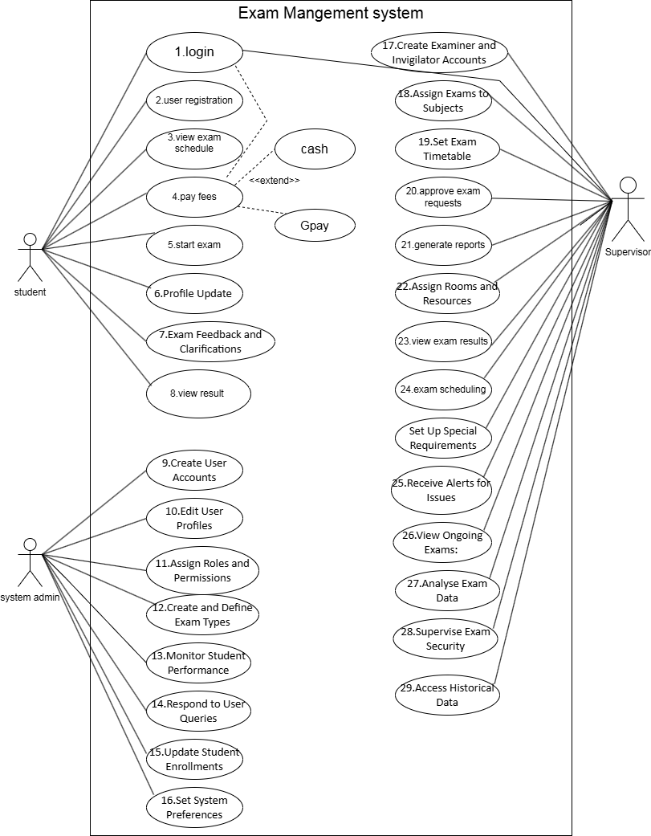
Figure 2.1-1 Use case diagram for exam management system

Activity diagram and Swimlane diagram

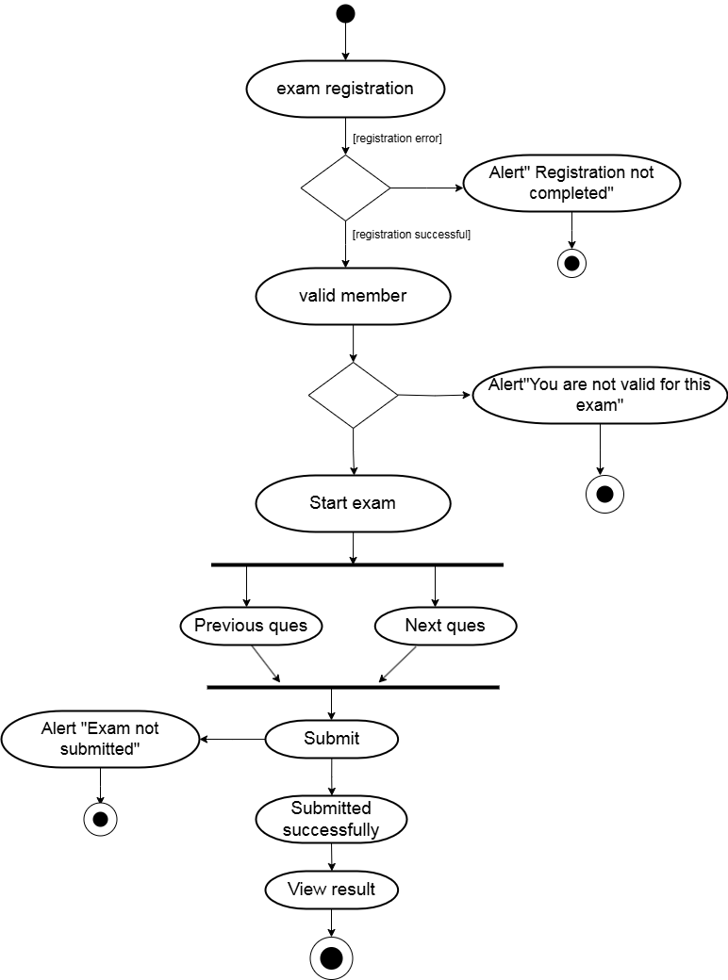
Figure 2.2-1 Activity diagram for exam registration
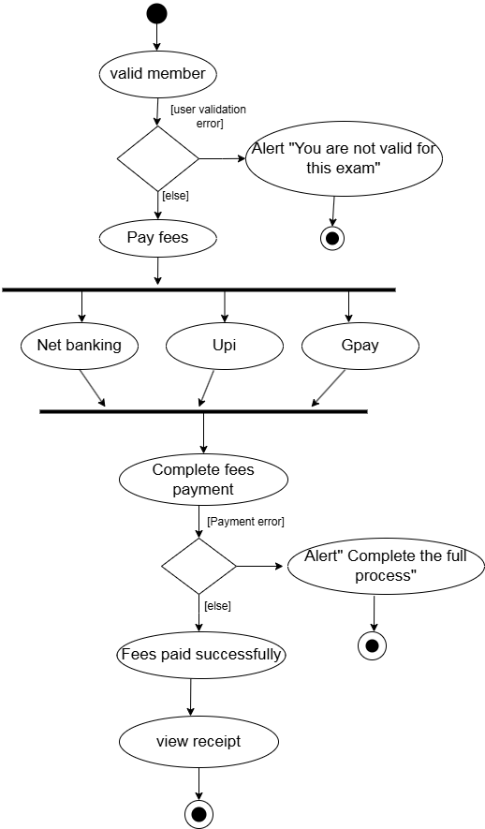
Figure 2.2-2 Activity diagram for exam payment

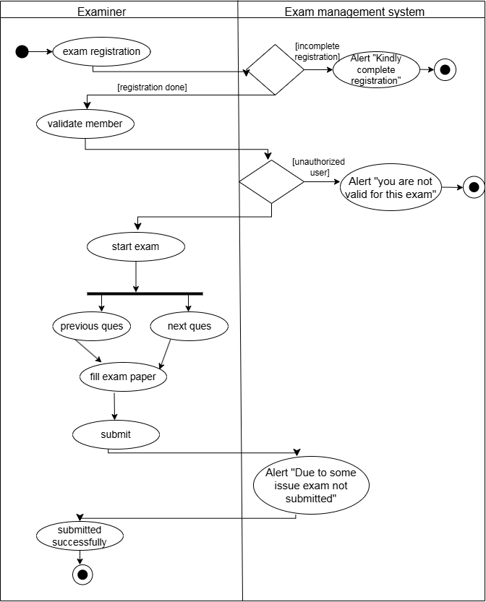
Figure 2.2-2 Swimlane diagram for giving exam

Sequence diagram

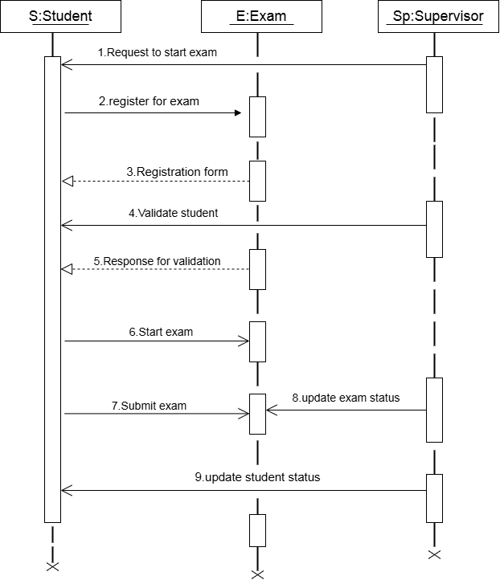
Figure 2.3-1 Sequence diagram for giving exam
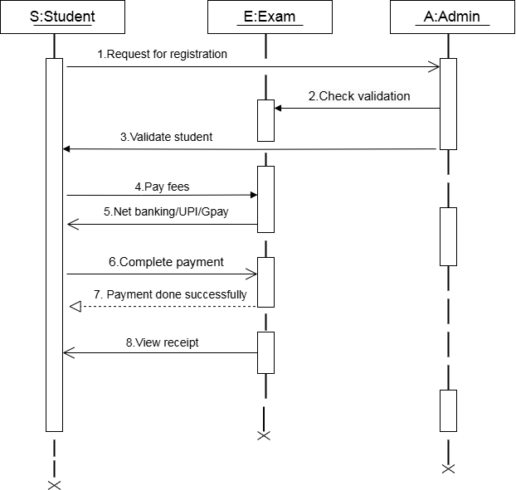

Figure 2.3-2 Sequence diagram for payment

State diagram

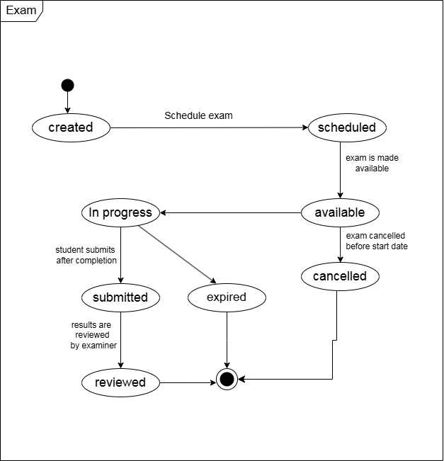
Figure 2.4-1 State diagram of Exam

Class diagram

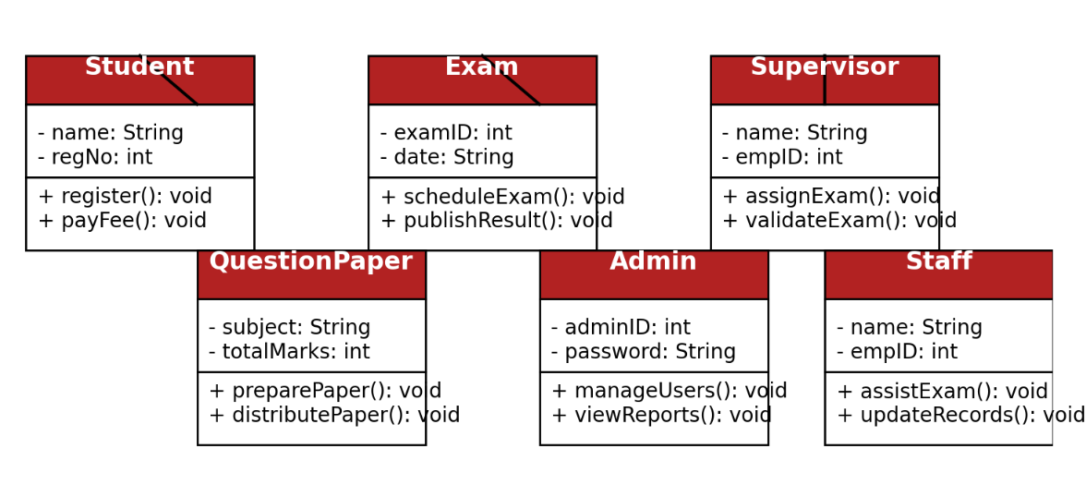
Figure 2.5-1 Class diagram for exam management system

Data flow diagram

Context diagram (level-0)
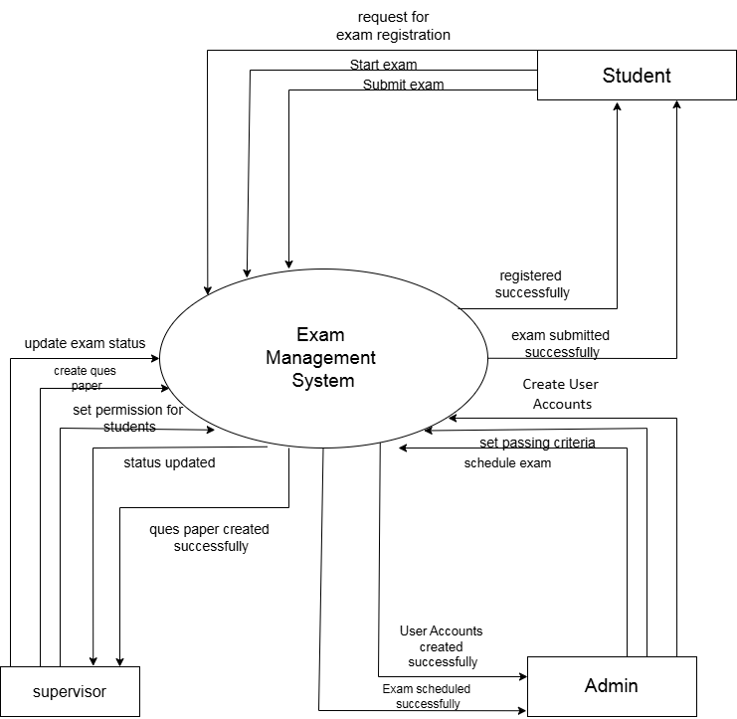

Figure 2.6-1 Context diagram for exam management system

DFD Level-1
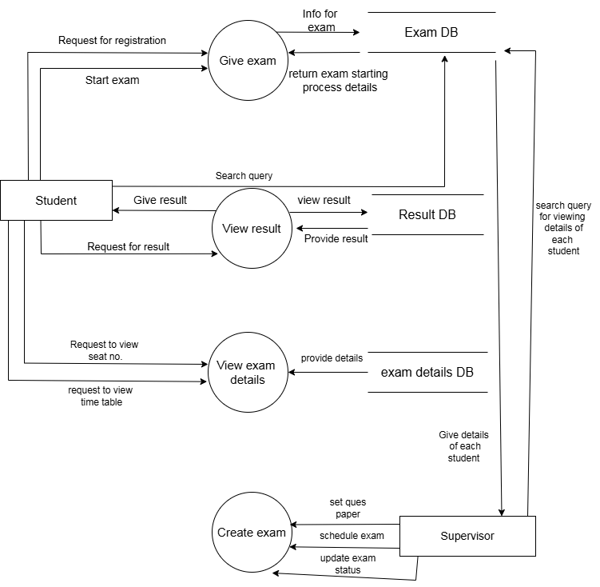
Figure 2.6-2 DFD level-1 for exam management system

External interface requirement (Screens)

Screen-1: Registration Form

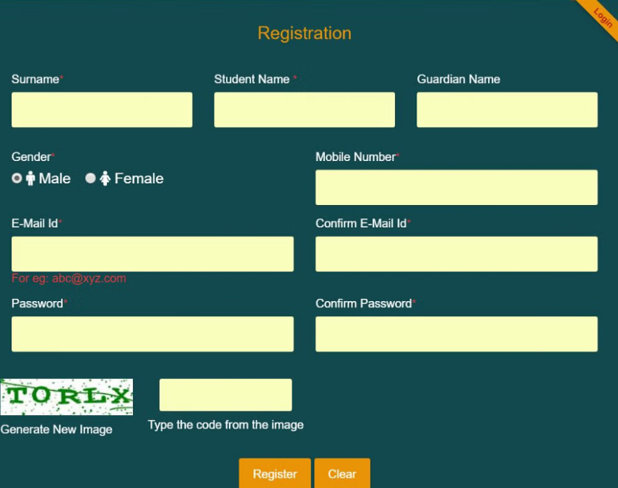
Figure 3.1-1 Screen-1: Registration Form

Purpose: This form will allow the target end-users to register in the system. To register, the following information will be encoded in the system.

Table 3.1-1 Screen element of Registration form
Sr. | Screen Element | Input Type | O/M | 1/N | Description
1 | Surname | Textbox | M | 1 | Input field to enter the user's surname.
2 | Student Name | Textbox | M | 1 | Input field to enter the student's full name.
3 | Guardian Name | Textbox | O | 1 | Input field to enter the guardian's name.
4 | Gender | Radio Button | M | 1 | Options to select the user's gender (Male/Female).
5 | Mobile Number | Textbox | M | 1 | Input field for the user's mobile phone number.
6 | E-Mail ID | Textbox | M | 1 | Input field for entering the user's email address.
7 | Confirm E-Mail ID | Textbox | M | 1 | Input field to re-enter and confirm the user's email address.
8 | Password | Password Field | M | 1 | Input field to set the user's password.
9 | Confirm Password | Password Field | M | 1 | Input field to confirm the entered password.
10 | CAPTCHA Image | CAPTCHA | M | 1 | Displays an image with a code to verify user input.
11 | CAPTCHA Input | Textbox | M | 1 | Input field for typing the CAPTCHA code displayed in the image.
12 | Generate New Image | Button | O | 1 | Button to refresh and generate a new CAPTCHA code.
13 | Register | Button | M | 1 | Submits the form and registers the user with the entered details.
14 | Clear | Button | O | 1 | Resets or clears all input fields in the form.

Screen-2: Exam Schedule Form
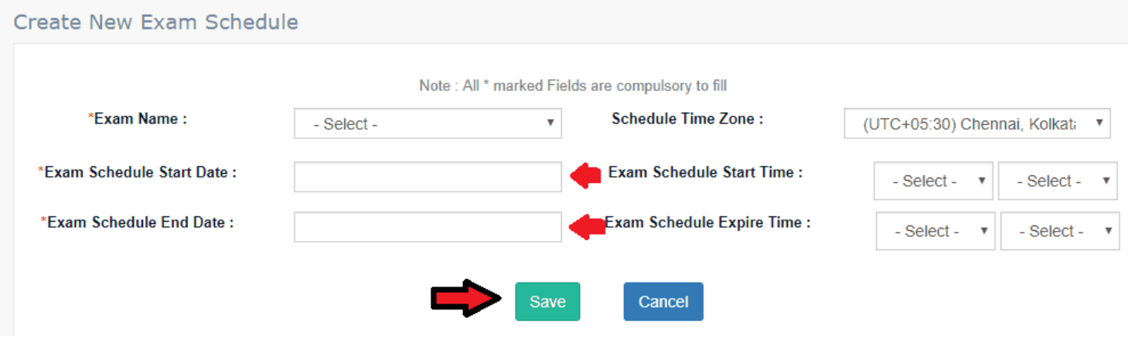
Figure 3.2-1 Screen-2: Exam Schedule Form
Purpose: This form is to allow administrators to schedule exams by specifying details such as the exam name, start and end dates, times, and time zone. It ensures proper configuration and management of exam schedules within the system.

Table 3.2-1 Screen element of exam schedule form
Sr. | Screen Element | Input Type | O/M | 1/N | Description
1 | Exam Name | Dropdown | M | 1 | Allows the user to select the exam name from a predefined list.
2 | Schedule Time Zone | Dropdown | M | 1 | Allows the user to choose the time zone for the exam schedule.
3 | Exam Schedule Start Date | Date Picker | M | 1 | Specifies the start date of the exam schedule.
4 | Exam Schedule Start Time | Time Picker | M | 1 | Specifies the start time of the exam schedule.
5 | Exam Schedule End Date | Date Picker | M | 1 | Specifies the end date of the exam schedule.
6 | Exam Schedule Expire Time | Time Picker | M | 1 | Specifies the expiration time for the exam schedule.
7 | Save | Button | M | 1 | Saves the entered data and creates a new exam schedule.
8 | Cancel | Button | O | 1 | Cancels the action and discards the entered data.
9 | Instruction Text ("Note...") | Text (Static) | O | 1 | Provides instructions or guidelines for filling out the form.

Screen-3: Retake exam Form
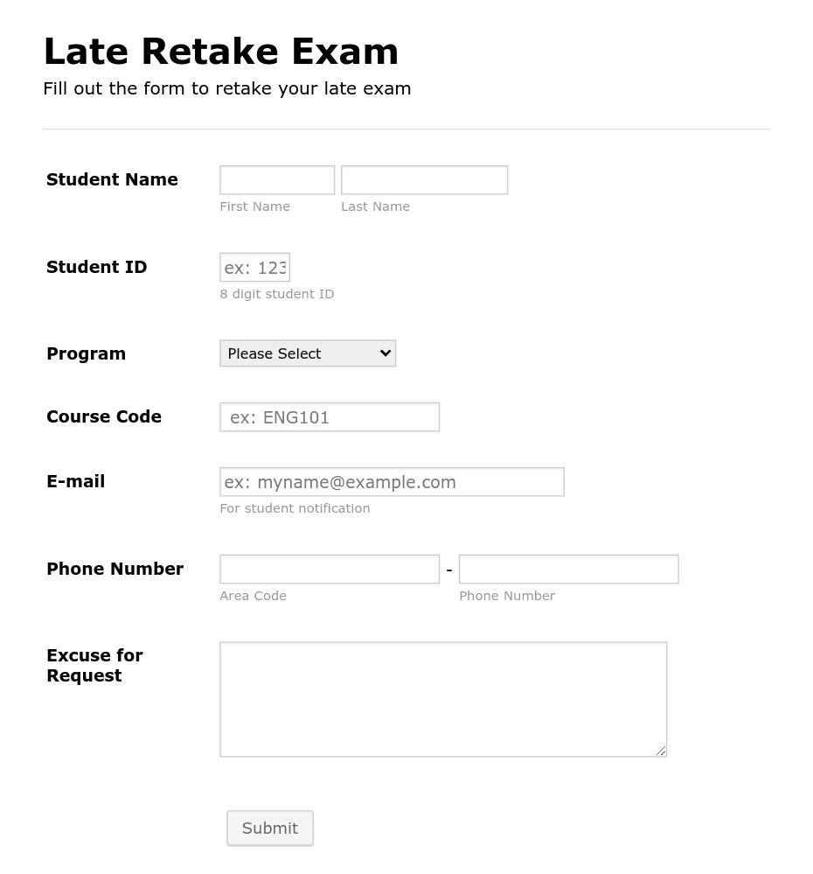
Figure 3.3-1 Screen-3: Retake Exam Form

Purpose: This form is to allow students to formally request a retake of an exam they missed. Students must provide their personal information, course details, and the reason for their request. This ensures proper documentation and communication for approval or follow-up by the academic institution.
Table 3.3-1 Screen element of Retake Exam form
Sr. | Screen Element | Input Type | O/M | 1/N | Description
1 | Student Name | Text Box | M | 1 | Input field for entering the student's first and last name.
2 | Student ID | Text Box | M | 1 | Input field for entering the unique 8-digit student ID.
3 | Program | Dropdown | M | 1 | Dropdown menu to select the student's academic program.
4 | Course Code | Text Box | M | 1 | Input field for entering the course code for the exam retake.
5 | E-mail | Text Box | M | 1 | Input field for entering the student's email address.
6 | Phone Number | Text Box | M | 1 | Input fields for entering the area code and phone number.
7 | Excuse for Request | Text Area | O | 1 | Text area to describe the reason for requesting a retake.
8 | Submit Button | Button | M | 1 | Button to submit the form data for processing.

Screen-4: Profile Update Form

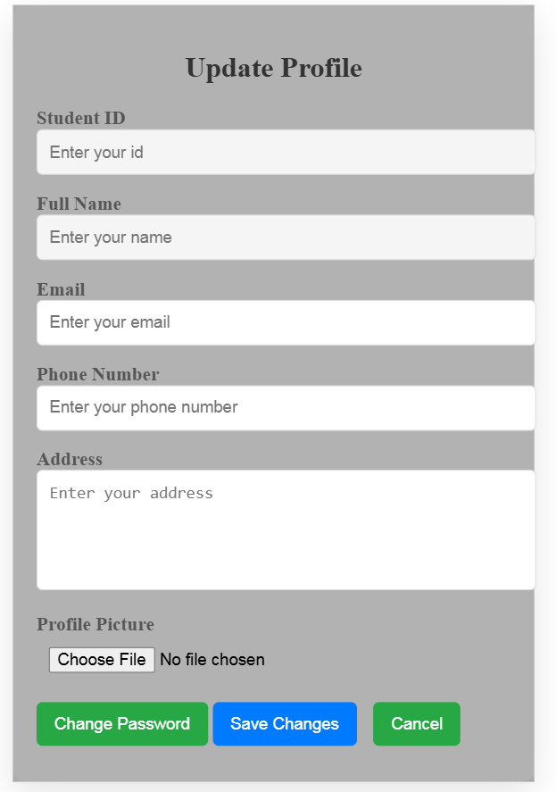

1
Figure 3.4-1 Screen-4: Result Form
Purpose: To allow students to update their profile information, such as email, phone number, address, and profile picture. It also provides an option to change the password. The form ensures that certain fields like Student ID and Full Name remain non-editable to maintain authenticity.

Table 3.4-1 Screen element of Result form

Sr. | Screen Element | Input Type | O/M | 1/N | Description
1 | Student ID | Text (Disabled) | M | 1 | Displays the unique Student ID. This field is non-editable.
2 | Full Name | Text (Disabled) | M | 1 | Displays the full name of the student. This field is non-editable.
3 | Email | Email Input | M | 1 | Allows the student to enter or update their email address.
4 | Phone Number | Text Input | M | 1 | Allows the student to enter or update their phone number.
5 | Address | Textarea Input | M | 1 | Allows the student to enter or update their home address.
6 | Profile Picture | File Upload Input | O | 1 | Allows the student to upload a new profile picture if needed.
7 | Change Password | Button (Action) | O | 1 | Provides an option to navigate to the Change Password page or modal.
8 | Save Changes | Button (Action) | M | 1 | Allows the student to save the updated profile information.
9 | Cancel | Button (Action) | O | 1 | Allows the student to cancel the update and close the modal/form without saving changes.

Screen-5: Exam Grade Entry Form

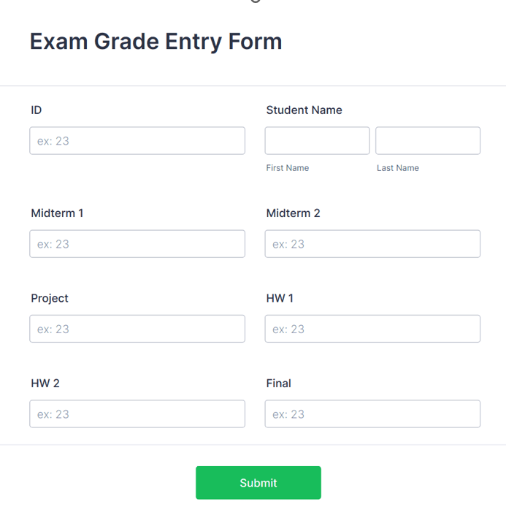
Figure 3.5-1 Screen-5: Exam Grade Entry Form
Purpose: To collect and input student grades for various assessments, such as midterms, homework, projects, and the final exam. To associate the grades with the student's ID and name for identification and record-keeping purposes. To submit the entered data for further processing or evaluation in the grading system.

Table 3.5-1 Screen element of Exam Grade Entry form

Sr. | Screen Element | Input Type | O/M | 1/N | Description
1 | ID | Text Field | M | 1 | Field to enter the student's unique ID.
2 | First Name | Text Field | M | 1 | Field to input the student's first name.
3 | Last Name | Text Field | M | 1 | Field to input the student's last name.
4 | Midterm 1 | Text Field | M | 1 | Field to input the grade for Midterm 1.
5 | Midterm 2 | Text Field | M | 1 | Field to input the grade for Midterm 2.
6 | Project | Text Field | M | 1 | Field to input the grade for the project.
7 | HW 1 | Text Field | M | 1 | Field to input the grade for Homework 1.
8 | HW 2 | Text Field | M | 1 | Field to input the grade for Homework 2.
9 | Final | Text Field | M | 1 | Field to input the grade for the final exam.
10 | Submit Button | Button | M | 1 | Button to submit the entered grades.

Screen-6: Create Examiner and Invigilator Accounts

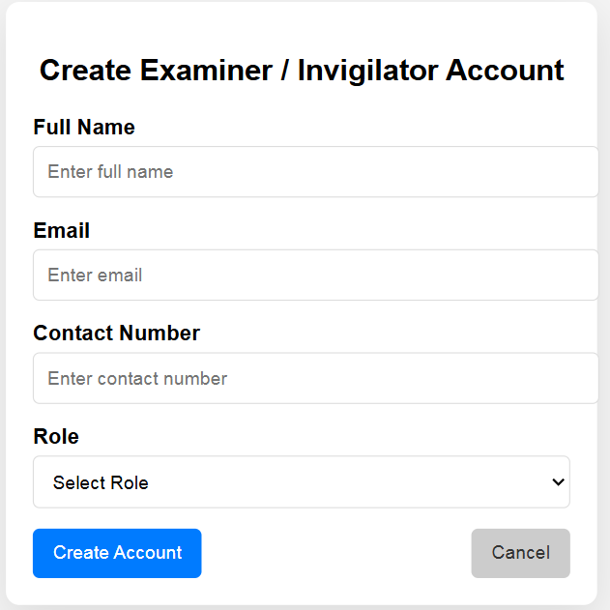
Figure 3.6-1 Screen-6: Create examiner/invigilator accounts

Purpose: To allow the Supervisor to create accounts for Examiners or Invigilators by entering their Full Name, Email, Contact Number, and Role. This ensures that authorized personnel can be added to the system to manage or supervise examinations. The form also provides options to either Create Account or Cancel the operation.

Table 3.6-1 Screen element of create examiner/invigilator accounts form

Sr. | Screen Element | Input Type | O/M | 1/N | Description
1 | Full Name | Textbox (Input) | M | 1 | Allows the user to enter the Full Name of the Examiner/Invigilator.
2 | Email | Textbox (Input) | M | 1 | Captures the Email Address of the Examiner/Invigilator.
3 | Contact Number | Textbox (Input) | M | 1 | Allows the user to enter the Contact Number of the Examiner/Invigilator.
4 | Role | Dropdown (Select) | M | 1 | Allows the user to select a role (Examiner or Invigilator) from the dropdown.
5 | Create Account | Button | M | 1 | On clicking this button, the account will be created and data will be saved.
6 | Cancel | Button | O | 1 | On clicking this button, the form will be cancelled without saving any data.

Screen-7: Respond to User Queries

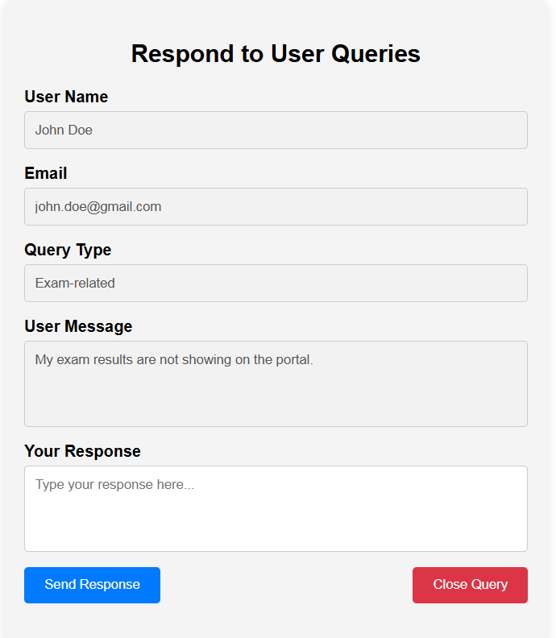
Figure 3.7-1 Screen-7: Respond to user Queries

Purpose: This screen is designed for the Admin to respond to user queries raised by students, examiners, or other users. The admin can view the user's details, query type, and message and provide an appropriate response. Additionally, the admin can send a response or close the query after resolution.

Table 3.7-1 Screen element of Respond to user Queries

Sr. | Screen Element | Input Type | O/M | 1/N | Description
1 | User Name | Text (Disabled) | M | 1 | Displays the name of the user who raised the query. This field is non-editable.
2 | Email | Email (Disabled) | M | 1 | Displays the email ID of the user who raised the query. This field is non-editable.
3 | Query Type | Text (Disabled) | M | 1 | Displays the type of query like Exam-related, Login issue, etc. This field is non-editable.
4 | User Message | Textarea (Disabled) | M | 1 | Displays the message sent by the user regarding the query. This field is non-editable.
5 | Your Response | Textarea | M | 1 | Allows the Admin to type their response to the user’s query.
6 | Send Response Button | Button | M | 1 | Sends the typed response to the user via email or notification.

Database design

List of Tables
- Exam
- Supervisor
- Admin
- Student
- Subject
- Ques Paper

Table 4.1-1 Table: Exam
Column | Data Type | Null | Keys & Constrains | Default Value & Description
Exam ID | int | NN | PK (Auto Increment) | Unique identifier for each exam
Exam Name | varchar(100) | NN |  | Name of the exam
Supervisor ID | int | NN | FK (Reference: Supervisor) | Links the exam to a supervisor
Exam Date | date | NN |  | Date of the exam
Duration | time | NN |  | Duration of the exam (hours and minutes)
Total Marks | int | NN |  | Total marks for the exam
Created At | datetime | AN | Default: GetDate() | Record creation

Table 4.1-2 Table: Supervisor
Column | Data Type | Null | Keys & Constrains | Default Value & Description
Supervisor ID | int | NN | PK (Auto Increment) | Unique identifier for each supervisor
Name | varchar(100) | NN |  | Supervisor name
Email | varchar(100) | NN | UNIQUE | Supervisor email
Password Hash | varchar(255) | NN |  | Securely hashed password
Created At | datetime | AN | Default: GetDate() | Record creation

Table 4.1-3 Table: Admin
Column | Data Type | Null | Keys & Constrains | Default Value & Description
Admin ID | int | NN | PK (Auto Increment) | Unique identifier for each admin
Name | varchar(100) | NN |  | Admin name
Email | varchar(100) | NN | UNIQUE | Admin email
Password Hash | varchar(255) | NN |  | Securely hashed password
Role | enum('Admin') | AN | Default: 'Admin' | Role of the admin
Created At | datetime | AN | Default: GetDate() | Record creation

Table 4.1-4 Table: Student
Column | Data Type | Null | Keys & Constrains | Default Value & Description
Student ID | int | NN | PK (Auto Increment)
Student Name | Varchar (100) | AN
Gender | Varchar (100) | AN
DOB | Date Time | AN
Department | Varchar (100) | AN
Contact | Number (10,0) | AN

Table 4.1-5 Table: Subject
Column | Data Type | Null | Keys & Constrains | Default Value & Description
Subject ID | int | NN | PK (Auto Increment) | Unique identifier for each subject
Subject Name | varchar(100) | NN |  | Name of the subject
Code | varchar(20) | NN | UNIQUE | Unique subject code (e.g., "MATH101")
Supervisor ID | int | NN | FK (Reference: Supervisor) | Links the subject to a specific supervisor
Created At | datetime | AN | Default: GetDate() | Record creation

Table 4.1-6 Table: Ques paper

Column | Data Type | Null | Keys & Constrains | Default Value & Description
Question Paper ID | int | NN | PK (Auto Increment) | Unique identifier for each question paper
Title | Varchar (100) | NN |  | Title of the question paper
Exam ID | int | NN | FK (Reference: Exam) | Links the question paper to an exam
Subject ID | int | NN | FK (Reference: Subject) | Links the question paper to a subject
Total Questions | int | NN |  | Total number of questions in the paper
Total Marks | int | NN |  | Total marks for the question paper
Created At | datetime | AN | Default: Get Date() | Record creation

Stories and Scenario

Story-1: Add New Exam in Exam Management System

Story # S1 | : | As an Exam Administrator,  I want to add a new exam to the exam management system,  So that students and faculty can easily access and manage exam-related information.
Priority | : | High
Estimate | : | XL
Reason | : | The addition of a new exam to the system is crucial for ensuring that exam schedules, details, and resources are up-to-date and accessible to all stakeholders.

Scenario# S1.1
Scenario# S1.1 | : | Adding a New Exam with Valid Information
Prerequisite | : | The Exam Administrator is logged in to the Exam Management System.
Acceptance Criteria | : | Given: The Exam Administrator is navigated to the exam management page.  Valid exam information, including exam title, subject, date, time, duration, and other relevant details, is provided.  When:  The Exam Administrator selects the "Add New Exam" option.  The Exam Administrator enters valid exam details.  The Exam Administrator clicks the "Save" button to add the exam to the system.  Then: The system successfully adds the exam to the database. The Exam Administrator receives a confirmation message with the exam's unique identification number.

Scenario# S1.2
Scenario# S1.2 | : | Adding a New Exam with Missing Required Fields.
Prerequisite | : | The Exam Administrator is logged in to the Exam Management System.
Acceptance Criteria | : | Given: The Exam Administrator is navigated to the exam management page  Some required fields (e.g., exam title, date, or subject) are left blank.  When: The Exam Administrator selects the "Add New Exam" option.  The Exam Administrator enters partial exam details (missing required fields).  The Exam Administrator clicks the "Save" button to add the exam to the system.  Then: The system displays an error message indicating which required fields are missing.  The exam is not added to the database.  The Exam Administrator is prompted to fill in the missing fields.

Scenario# S1.3
Scenario# S1.3 | : | Adding a New Exam with Duplicate Exam Title.
Prerequisite | : | The Exam Administrator is logged in to the Exam Management System.
Acceptance Criteria | : | Given: The Exam Administrator is navigated to the exam management page.An exam with the same title already exists in the system.  When: The Exam Administrator selects the "Add New Exam" option.  The Exam Administrator enters exam details, including a title that matches an existing exam in the system.  The Exam Administrator clicks the "Save" button to add the exam to the system.  Then: The system displays an error message indicating that an exam with the same title already exists.  The exam is not added to the database.  The Exam Administrator is prompted to enter a unique exam title..

Story-2: View Exam Schedule
Story # S2 | : | As a Student,  I want to view my exam schedule in the exam management system,  So that I can plan my study schedule and be prepared for my exams.
Priority | : | High
Estimate | : | M
Reason | : | Students need timely access to their exam schedules to manage their time effectively and avoid missing exams.

Scenario# S2.1
Scenario# S2.1 | : | View Exam Schedule Successfully.
Prerequisite | : | The Student is logged in to the Exam Management System, and exams have been scheduled for the student.
Acceptance Criteria | : | Given: The Student is navigated to the dashboard or exam schedule page.  Exams have been scheduled for the student by the Exam Administrator.  When: The Student selects the "View Exam Schedule" option.  Then: The system displays the student's exam schedule, including details such as exam title, date, time, duration, and location (if applicable).  The schedule is displayed in a clear and organized format (e.g., table or calendar view).

Scenario# S2.2
Scenario# S2.2 | : | View Exam Schedule with No Scheduled Exams.
Prerequisite | : | The Student is logged in to the Exam Management System, and no exams have been scheduled for the student.
Acceptance Criteria | : | Given: The Student is navigated to the dashboard or exam schedule page.  No exams have been scheduled for the student.  When: The Student selects the "View Exam Schedule" option.  Then: The system displays a message indicating that no exams have been scheduled for the student.  The message may include instructions to contact the Exam Administrator or check back later.

Scenario# S2.3
Scenario# S2.3 | : | View Exam Schedule with Filtered Results.
Prerequisite | : | The Student is logged in to the Exam Management System, and multiple exams have been scheduled for the student.
Acceptance Criteria | : | Given: The Student is navigated to the dashboard or exam schedule page.  Multiple exams have been scheduled for the student, including upcoming and past exams.  When: The Student selects the "View Exam Schedule" option.  The Student applies a filter to view only upcoming exams.  Then: The system displays only the upcoming exams, filtered by the selected criteria (e.g., date range or status).  Past exams are excluded from the displayed results.  The filter options are intuitive and easy to use.

Story-3: Update Exam Details in the Exam Management System
Story # S3 | : | As an Exam Administrator,  I want to update the details of an existing exam in the exam management system,  So that any changes to the exam schedule, subject, or other details are reflected accurately for students and faculty.
Priority | : | High
Estimate | : | L
Reason | : | Updating exam details is essential to ensure that the information remains accurate and up-to-date, especially when changes occur after the exam has been created.

Scenario# S3.1
Scenario# S3.1 | : | Update Exam Details with Valid Information.
Prerequisite | : | The Exam Administrator is logged in to the Exam Management System, and an exam already exists in the system.
Acceptance Criteria | : | Given: The Exam Administrator is navigated to the exam management page.  The exam to be updated is selected from the list of existing exams.  When: The Exam Administrator selects the "Edit Exam" option.  The Exam Administrator updates valid exam details (e.g., date, time, or duration).  The Exam Administrator clicks the "Save" button to save the changes.  Then: The system successfully updates the exam details in the database.  The Exam Administrator receives a confirmation message indicating that the exam details have been updated.

Scenario# S3.2
Scenario# S3.2 | : | Update Exam Details with Invalid Date.
Prerequisite | : | The Exam Administrator is logged in to the Exam Management System, and an exam already exists in the system.
Acceptance Criteria | : | Given: The Exam Administrator is navigated to the exam management page.  The exam to be updated is selected from the list of existing exams.  When: The Exam Administrator selects the "Edit Exam" option.  The Exam Administrator updates the exam date to a past date (invalid).  The Exam Administrator clicks the "Save" button to save the changes.  Then: The system displays an error message indicating that the exam date cannot be in the past.  The exam details are not updated in the database.  The Exam Administrator is prompted to enter a valid future date.

Scenario# S3.3
Scenario# S3.3 | : | Update Exam Details with Duplicate Exam Title
Prerequisite | : | The Exam Administrator is logged in to the Exam Management System, and an exam already exists in the system.
Acceptance Criteria | : | Given: The Exam Administrator is navigated to the exam management page.  The exam to be updated is selected from the list of existing exams.  When: The Exam Administrator selects the "Edit Exam" option.  The Exam Administrator updates the exam title to match the title of another existing exam.  The Exam Administrator clicks the "Save" button to save the changes.  Then: The system displays an error message indicating that the exam title already exists.  The exam details are not updated in the database.  The Exam Administrator is prompted to enter a unique exam title..

Test cases
Project Name: | Exam Management System | Test Designed by: | Baru Priyanshi
Module Name: | Exam Dashboard | Test Designed date: | 21-02-2025
Release Version: | 1.0 | Test Executed by: | Baru Priyanshi
 |  | Test Execution date: | 21-02-25

Pre-condition: Web application should be accessible
Test Case ID | Test Title | Test Type | Description | Test Case ID
TC_001 | View Exam Schedule with valid credentials | GUI | Verify that the user can view the exam schedule after logging in with valid credentials | TC_001
TC_002 | Edit Exam Details in Exam Management System | Functional | Verify that the user can successfully edit exam details and the changes are reflected in the exam schedule | TC_002
TC_003 | Add New Exam Details | Functional | Verify that the admin can add new exam details successfully | TC_003

Test Case Title | View Exam Schedule with valid credentials
Test Type | GUI
Test Priority | High
Pre-condition | User must be logged in

Test Step | Test Case Description | Expected Result | Actual Result | Status | Comment | Data | BUG ID
1 | Access Exam Management System URL | The site launched properly | Site launched successfully | Pass |  | https://exammanagementsystem.com
2 | Navigate to Exam Schedule page | Exam Schedule page should load successfully | Exam Schedule page loaded successfully | Pass
3 | Verify Exam Schedule is displayed | Exam Schedule should be displayed with all details | Exam Schedule displayed with all details | Pass | Step required when human action validation perform | get captcha from image which is near by captcha field
4 | Enter exam details and click "Save" | Exam details should be saved successfully | Exam details saved successfully | Pass |  | Exam Name: Mid-Term, Date: 2023-11-15, Time: 10:00 AM
5 | Verify search functionality in Exam Schedule | The user should be able to search for an exam using the search bar | Search results display the correct exams | Pass |  | Search: "Mid-Term"

Test Case Title | Edit Exam Details in Exam Management System
Test Type | Functional
Test Priority | Medium
Pre-condition | The user must be logged in as an admin to edit exam details.

Test Step | Test Case Description | Expected Result | Actual Result | Status | Comment | Data | Bug ID
1 | Navigate to the Exam Management System | The system should launch successfully | System launched successfully | Pass
2 | Navigate to the Exam Schedule page | Exam Schedule page should load successfully | Exam Schedule page loaded successfully | Pass
3 | Select an existing exam and click on "Edit" | Exam details should be displayed in editable mode | Exam details displayed for editing | Pass |  | Exam Name: Mid-Term, Date: 2023-11-15
4 | Update exam details and click "Save" | Updated exam details should be saved successfully | Exam details updated successfully | Pass |  | Updated Date: 2023-11-20 | Bug_002

Test Case Title | Add new exam details
Test Type | Functional
Test Priority | High
Pre-condition | User must be logged in as an admin

Test Step | Test Case Description | Expected Result | Actual Result | Status | Comment | Data | Bug ID
1 | Navigate to the "Add Exam" page | "Add Exam" page should load successfully | "Add Exam" page loaded successfully | Pass |  | https://accounts.google.com/ServiceLogin
2 | Enter valid exam details (Exam Name, Date, Time, and Duration) | Exam details should be accepted | Exam details accepted | Pass |  | Exam Name: Final Term, Date: 2023-12-20, Time: 09:00 AM, Duration: 3 hours
3 | Click on the "Save" button | Exam details should be saved successfully | Exam details saved successfully | Pass
4 | Verify the newly added exam in the Exam Schedule | New exam should appear in the Exam Schedule | New exam appeared in the Exam Schedule | Pass
5 | Attempt to add an exam with missing mandatory fields | The system should display validation messages | Validation messages displayed | Pass
6 | Attempt to add an exam with a past date | The system should prevent scheduling exams in the past | Exam was added successfully instead of showing an error | Fail |  |  | BUG_003

References

- http://www.w3schools.com/html/html_intro.asp
- https://www.w3schools.com/php/default.asp
- https://www.javatpoint.com/uml

